**Java Installation Guide:**

Steps:

1. Download Java 1.8 Version from below Path

<https://www.oracle.com/in/java/technologies/javase/javase8-archive-downloads.html>

1. Click on Java Version downloaded to Install
2. Check in Program Files for Installation
3. Setup System Environment Variables

Path: C:\Program Files\Java\jdk-18.0.1.1\bin

JAVA_HOME: C:\Program Files\Java\jdk-18.0.1.1

1. Check Java installation in CMD Prompt

**java -version**

**javac -version**

**Spring Tool Installation Steps:** IDE for Java Code Creation

1. Download Spring Tool IDE from below Path

<https://spring.io/tools>

1. Extract the Zip file from the downloaded folder
2. Create Spring Tool Shortcut on Desktop and Launch

**Spring Tool Configuration**

1. Create Workspace for storing Project Files
2. Create Sample Java Project
3. Setup JDK 1.8 Version in Spring Tool IDE

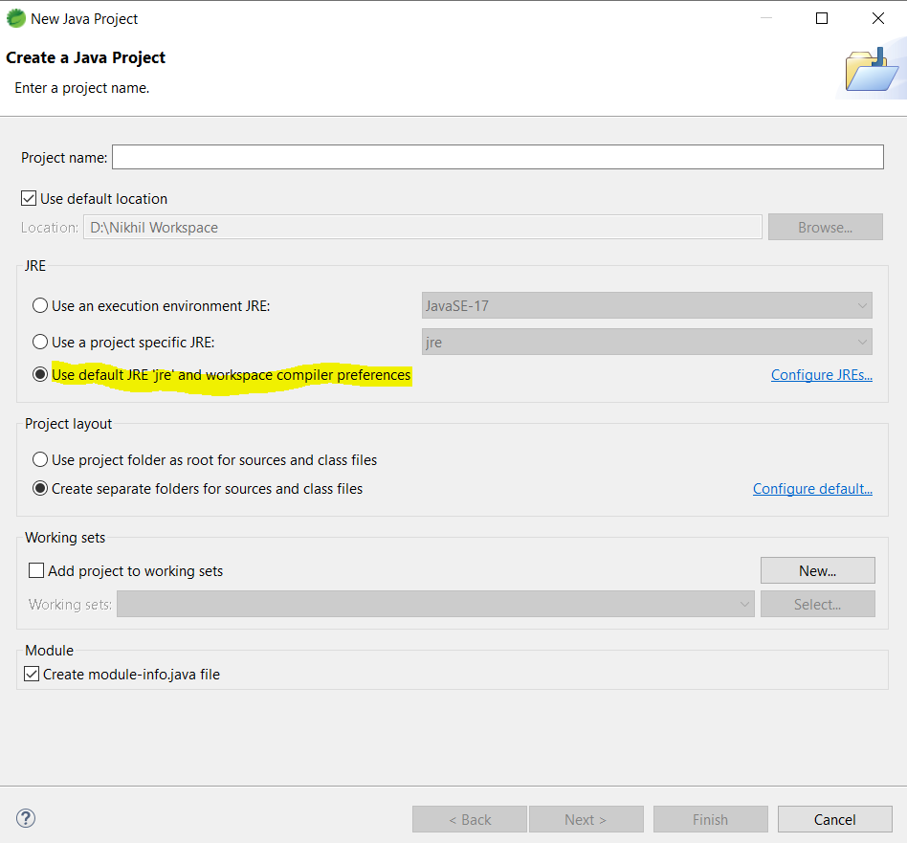

*Select JDK1.8 Path but not JRE Path

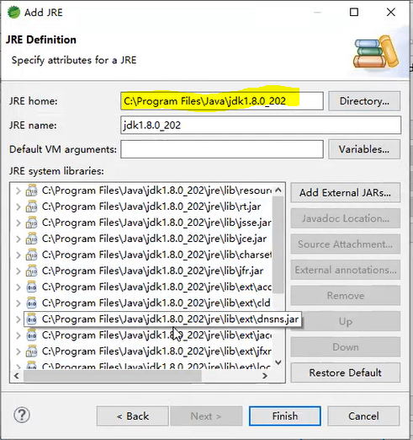

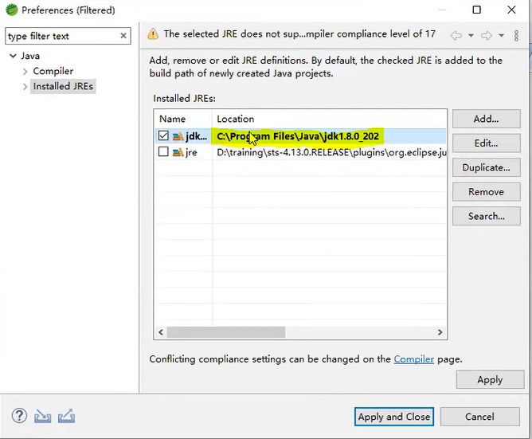

1. Setup Java Compiler in Spring Tool for JDK1.8

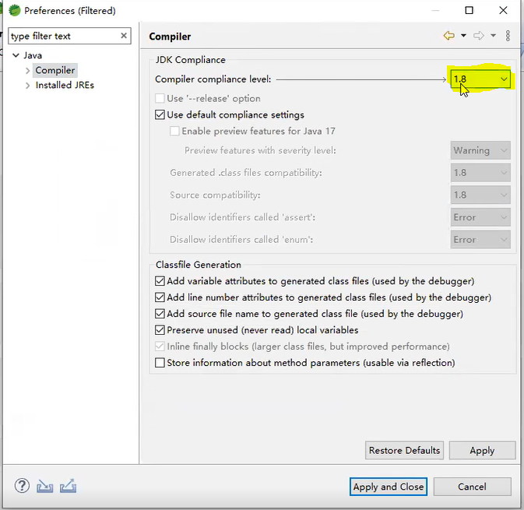

**Importing Java Working Project from GitHub**

1. Clone Working Project from GitHub

Use the URL Shared to clone the Project

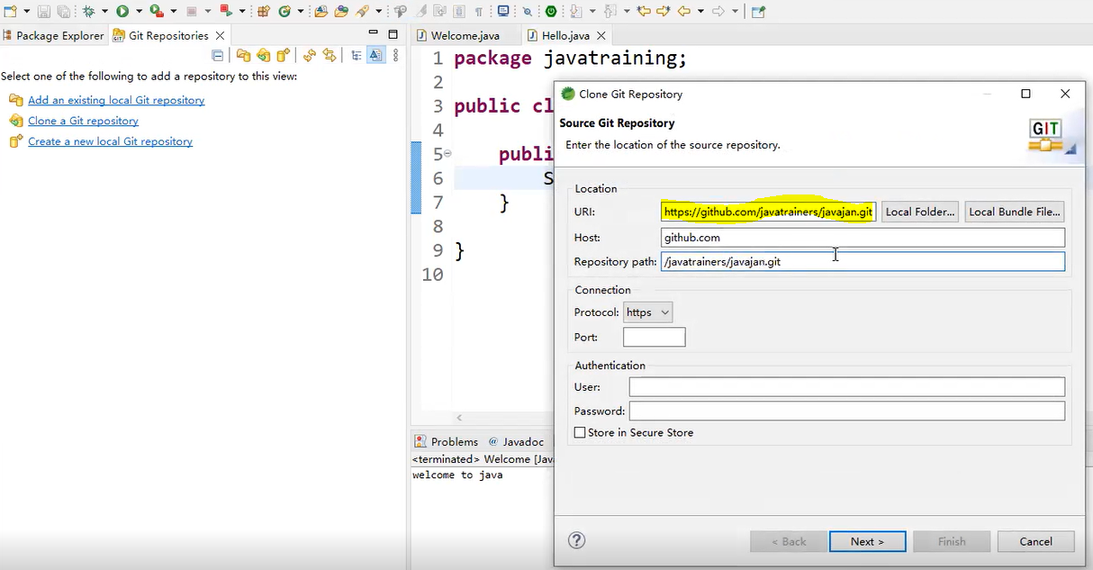

1. Import Project from Git Local Repository to Project Explorer

File🡪Import🡪General🡪Existing Project into Workspace🡪

**\*Copy the Project from Git Folder**

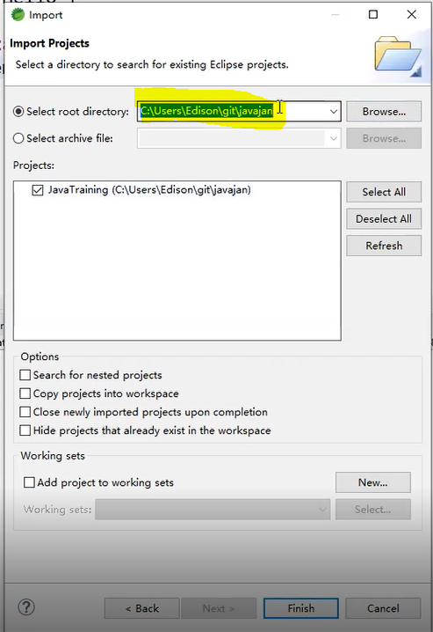

1. Pull the latest code every day from the GitHub Repository

Right Click on Project 🡪 Teams🡪Pull